**ASSIGNMENT 01 – Acquire a Web Host & Domain Name**

Students are required to have access to a Web Host account that they use to create and manage multiple CMS websites. In our first IT320 class, during class we did Activity 01, and we signed up for a shared web host account. In this assignment, you will record information about these accounts and verify that our new shared web host account has an “admin” email account for its domain.  
  
Additionally, we will do a few PHP problems, to test your understanding of the PHP material we covered in class.   
If you have difficulties completing this assignment, please inform the instructor and consider working with DePaul tutors.

**Instructions for completing template:***Replace* **[bracketed red text]** *with the requested information and change the* ***red text to black text.*** *Do not include full screen shot images, or full screen shots that are reduced in size. Use a snippet tool to capture parts of the screen and insert those images into the template.  
Please answer all questions.***Please do not alter template numbering.**

**PART A – Student & Assignment Information**

**1. Student Name: [STUDENT NAME – Aamir, Patel] [A01]**

**2. Student Contact Information:   
[Aamir8567@gmail.com] [A02]  
[Student Phone Number – (872) 985 4361] [A03]**

**Go back to the instructions and begin working on part B.**

**Part B – Shared Web Host Information**

1. Which shared web host account did you establish? Please list their name below.  
 **[NameCheap] [B01]**

**Part C – Student Shared Web Admin Email Account Check**

Most shared web hosts use Softaculous build scripts. These scripts are not the same as building WordPress form the Automatic (the company that owns WordPress) default build script.   
One of the default Softaculous options is the “admin email”.  
Softaculous has a default value of admin@“your doimain name”.  
So for your WordPress sites to build and work properly, your web host account must have this default email account. In the tutorial we checked and made one.   
  
In this part of the assignment, I want you to provide proof that the admin email account exists.   
Pantheon users can skip this part without losing any points.

1. Does your new web host account have an email account named “admin”?   
 **[NameCheap - Yes] [C01]**

**2. Did you create a forwarder email account   
[Yes]** **[C02]**

**3. Provide a screen capture of your Email forwarder accounts page that displays the forwarder email information**[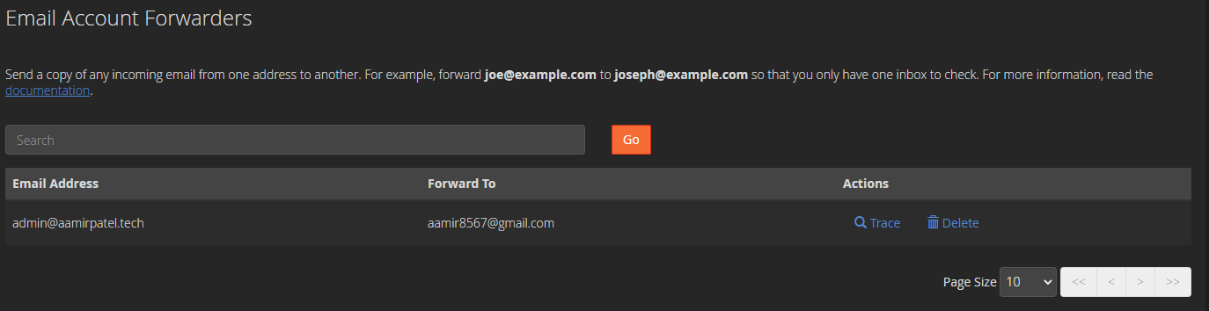] **[C03]**

**Go back to the instructions and begin working on part D.**

**Part D – INTRO to PHP Questions and Answers:**

1. List the five PHP variable naming rules below [D01]

|  |  |
| --- | --- |
| 1 | A variable can not start with a number |
| 2 | A variable must start with a $ sign followed by the variable name |
| 3 | The variable name must start with a letter or an underscore |
| 4 | Variables are case-sensitive |
| 5 | Variable can only contain alpha numeric characters and underscore, and no special characters. |

1. This question has two parts.   
   Part 1: Of the following PHP variables, which are valid and which are invalid? Part2: **If the variable is invalid, please list why it is invalid?  
   (HINT: there may be more than 1 error on the variable) [D02]**

|  |  |  |  |
| --- | --- | --- | --- |
| **No.** | **Variable** | **Is Valid (Yes/No)** | **If invalid, reason(s) why** |
| **1** | **$myNameIsBill** | **Yes** |  |
| **2** | **$#name-first** | **No** | **The first letter can not be a number, plus the name can not have special characters** |
| **3** | **$name_first** | **Yes** |  |
| **4** | **$name-first** | **No** | **The name has a special character ( - )** |
| **5** | **$ lostAmount** | **No** | **The name can not have spaces** |

**3.** Write PHP code that defines a PHP variable named $cost and assigns the $cost variable the value of 5.01 and then in another (different) PHP statement **use the echo function to display the $cost variable**. Write your code and test it in a web emulator (tester) like phptester.net. Take a screen capture of the code and output window and paste the capture in the box below, where it says  
<Your PHP capture here>

|  |
| --- |
| **[D03]** |
|  |

**4.** Is the variable $1234Abc a valid variable and if not, why not?   
Write your code and test it in a web emulator (tester) like phptester.net. Take a screen capture of the code and output window and paste the capture in the box below, where is says  
<Your PHP capture here>

|  |
| --- |
| **[D04]** |
| * It is NOT a valid variable, because it starts with numbers, and a variable name cannot start with numbers. |

**Go back to the instructions and begin working on part E.**

**Part E – Questions** about IT320 and WordPress CMS

Please write a few sentences, in your own words, to answer the following questions. Please do not copy and paste content from the web. Please write your answers in the box below each question. Most of these questions are from the assigned readings and D2L presentations.

1. List and describe 3 attributes (features) of Content Management Systems (CMS)?

|  |
| --- |
| * CMS based websites are easy to learn and expand, due to its great market of free plugins that you can use. * Security: - It allows you to set different roles for people with different access of the website. * Ability to change it up – CMS uses a database to store the contents and settings, so we can always change the way a website looks and feels without losing any data. |

1. Define and give an example of extensibility as it pertains to content management systems?

|  |
| --- |
| * Extensibility in content management is the ability to expand the system over time, as the needs increase in the future. An example of it is expanding an ecommerce site to accept different payment options, and instead of coding all of that yourself, you can use one of the open source plugins available on CMS marketplace, and get it done in a shorter time frame. |

1. List and describe the 2 different websites associated with a single CMS website and what are their purposes?

|  |
| --- |
| * The two different websites associated with a single CMS website are Front-End and Back-End. * The Front-End part of the website handles everything that the user can see, basically the look and feel of the website. * The Back-End part of the website handles everything related to the backend, I.E. the data, encryption, security, and modifying other contents of the webpage. |

1. List and describe 3 benefits and 3 risks of using CMS websites?

|  |
| --- |
| Benefits |
| * The first benefit of using a CMS website is that they are open source, and CMS tools are zero cost. * CMS sites are easy to expand by adding different plugins. * CMS sites store the settings and data in a database, which allows the user to change the look and feel with minimal effort and loss of data. |
| Risks |
| * Hosting a CMS site can be expensive, since you have to store it on the web, rather than your local machine. * Since all of the content is stored in the database, it adds a delay due to the webpage having to access database to get the content. * Security of a CMS website requires a lot of work, and knowledge about different bugs and glitches about different plugins that are out there. |

1. List and describe 3 differences between CMS websites and static HTML websites?

|  |
| --- |
| * CMS sites are easy to use and does not require coding knowledge. * CMS sites are hosted on a database, so they do not have static files to display. * CMS sites are easily expandable by adding different plugins to achieve different tasks. |

**Go back to the instructions and begin working on part F.**

**Part F - Assignment - Wrap Up:**

1. **Did you have any problem or issues completing this assignment besides time management issues:   
   [No] [F01]**  
   If you answered yes to this question, please elaborate and be specific.  
   If you had trouble with a specific question, please identify it by number and explain what you did not understand or had problems with.  
   I can only improve this assignment with your help.
2. **If you answered yes to this question, please elaborate and be specific.  
   If you had trouble with a specific question, please identify it by number and explain what you did not understand or had problems with.  
   I can only improve this assignment with your help.**

**[ ] [F02] *Only if you answered yes to F01**

**If you have questions or issues about this assignment please contact the instructor immediately.**   
Michael H Chase  
Mobile: 847-878-6225  
Office: 312-362-1352  
Email: [mchase2@cdm.depaul.edu](mailto:mchase2@cdm.depaul.edu)

Submit your completed template to D2L dropbox for assignment 01.

If you prefer not to navigate by hand to the D2L dropbox, take advantage of the dropbox link in the D2L Module 01 Assignment 01 section. This link will take you to the correct assignment dropbox location.

**Codeanywhere sub-account password and verification steps.**Before you can work next week’s tutorial or assignment, you must complete the Codeanywhere sub-account setup process.   
This includes (first) creating an account password and (second) resending and replying to a verification email. Details are in the Module 01 presentation:  
“M01 -06- Codeanywhere Account Signup”.   
Please follow through with completing the Codeanywhere new account set ASAP. Do not wait on this until it too late.   
The first Codeanywhere email link expires and if you run into issues because you waited too long, you may be late submitting the second assignment.